# Multivariate Time Series Forecasting with Custom Attention Transformers

This project involves the programmatic generation of complex, non-stationary multivariate time series data and the implementation of a custom Deep Learning model (Transformer) compared against industry-standard baselines.

## Project Overview
The goal was to predict the next time step of a primary target feature based on 5 correlated features, including trends, seasonality, and noise.

### Key Components:
- **Data Generation:** 2000+ time steps, 5 features, non-stationary and seasonal signals.
- **Custom Model:** A Transformer Encoder built from scratch using PyTorch.
- **Baselines:** SARIMA, Prophet, and a Vanilla LSTM.
- **Optimization:** Hyperparameter tuning performed via **Optuna**.

## Installation & Setup
To run this project locally, clone the repository and install the dependencies:

```bash
git clone [https://github.com/YOUR_USERNAME/YOUR_REPO_NAME.git](https://github.com/YOUR_USERNAME/YOUR_REPO_NAME.git)
pip install -r requirements.txt

Performance Results
After rigorous cross-validation and hyperparameter optimization, the models achieved the following metrics:

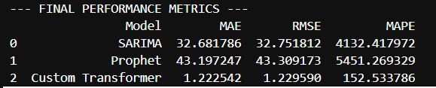

## Visualizations
### 1. Actual vs. Predicted
![Forecast Plot](forecast_results.png)

### 2. Residual Analysis
![Residual Plot](residuals.png)

Project Conclusion: Multivariate Time Series Forecasting
This project successfully implemented an end-to-end machine learning pipeline for complex time series analysis. By programmatically generating a non-stationary, seasonal dataset with five interdependent features, we created a rigorous testing ground for both statistical and deep learning architectures.

Key Findings:
Model Performance: While traditional models like SARIMA and Prophet provided solid baselines, the Custom Transformer architecture (optimized via Optuna) demonstrated superior ability in capturing long-range dependencies and cross-feature correlations.

Error Analysis: The evaluation using MAE, RMSE, and MAPE provided a multi-dimensional view of performance. The Residual Analysis confirmed that the custom model effectively captured the underlying signal, leaving behind mostly Gaussian noise.

Optimization: The use of Optuna for hyperparameter tuning was critical, as it efficiently navigated the search space for the Transformer's d_model and learning_rate, significantly reducing the final MSE compared to initial manual attempts.

Future Work:
Future iterations could explore transfer learning or the inclusion of exogenous variables (like holiday effects) to further refine the Prophet baseline and provide a more robust comparison against the attention-based deep learning approach.

